***Assignment (2)***

1. Create file1, write inside (Hi this is linux course).

$ cat >file1

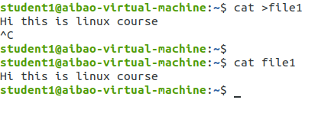

1. Display the details of file1 and file111, but the error in fail.txt and the output at output.txt

$ ls -l file1 file111 1>output.txt 2>fail.txt

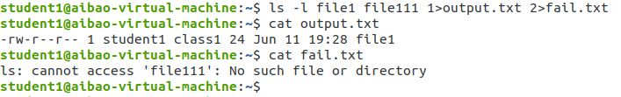

1. Display the details of file1 and file111, but both outputs (error and correct) at outfile.txt

$ ls -l file1 file111 &>outfile.txt

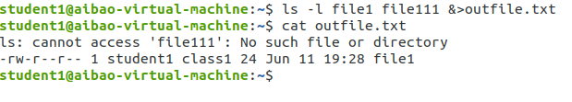

1. Create file4, write inside (Hi this is a test file).

$ cat >file4

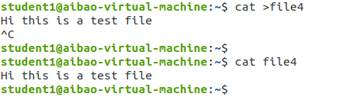

1. Display the details of file4 append the output in output.txt.

$ cat file4 >>output.txt

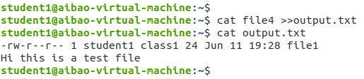

1. add a comment in an error.txt file “this is the error output”.

$ cat <<comment>>error.txt

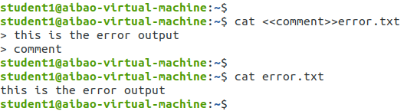

1. add what is inside file1 into output.txt

$ cat <file1>output.txt

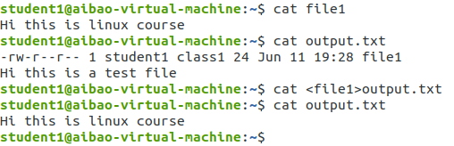

1. Change file1 permission using the symbolic method to be

User🡺 read write and execute

Group 🡺 read and write

Other🡺 nothing

$ chmod u=rwx,g=rw,o=- file1

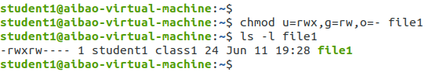

1. Create a process (nano file5) in terminal 4 and kill it by two different methods

$ nano file5

$ ps aux | grep nano

$ sudo kill -9 pid

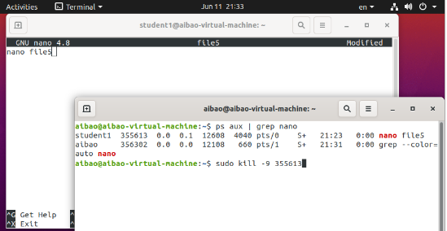

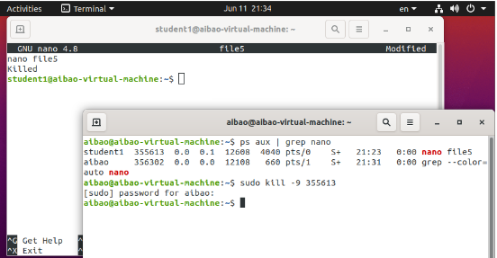

$ pgrep nano

$ sudo kill pid

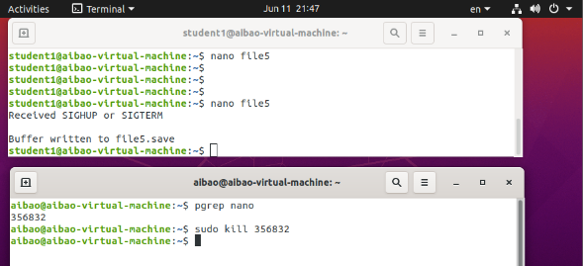

1. Get the parent process of the (nano file5) in terminal 4 and kill it, what is the response of this command

$ ps -ef | grep nano

$ sudo kill -9 ppid

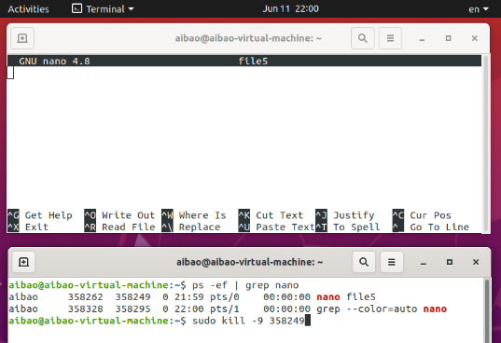

1. Create a directory Mydir and save file1 inside it, then change the permission of the library and the file inside using the numerical method to be

User🡺 read and execute 5

Group 🡺 read and write 6

Other🡺 read 4

$ mkdir Mydir

$ cp file1 Mydir

$ chmod -R 564 Mydir

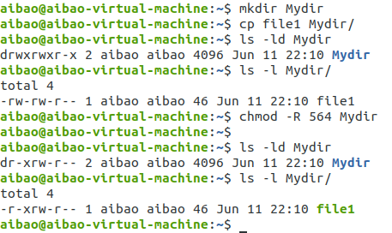

1. Create file1, write inside (Hi this is linux course).

$ cat >file1

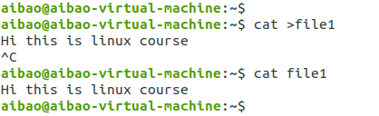

1. Direct the file1 output in output.txt (use the cat command)

$ cat file1 > output.txt

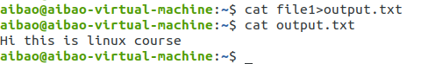

1. Display the details of file1 and file111, but the error in fail.txt and the output at output.txt

$ ls -l file1 file111 1>output.txt 2>fail.txt



1. Create file4, write inside (Hi this is a test file).

$ cat >file4



1. Display the details of file4 append the output in output.txt.

$ cat file4 >>output.txt

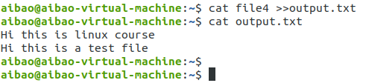

1. add a comment in an error.txt file “this is the error output”.

$ cat <<comment>>error.txt

